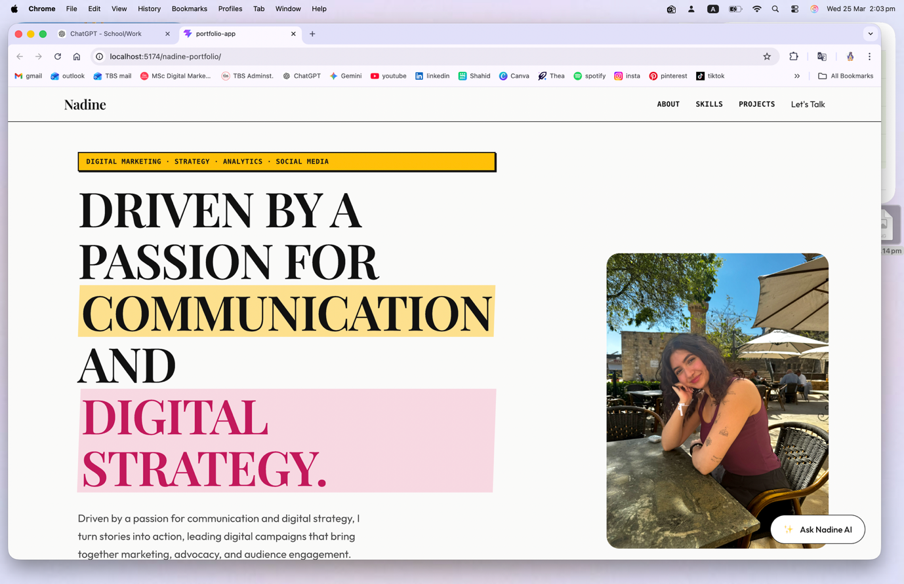
I think the title can be smaller in font size a bit? And let it be catchy, not the same word for word as what I have immediately in the text below. Moreover, if we can crop my image actually, like up to where my head is a bit up, and where I put my arms on the table, so like cropping a bit also from the way down.

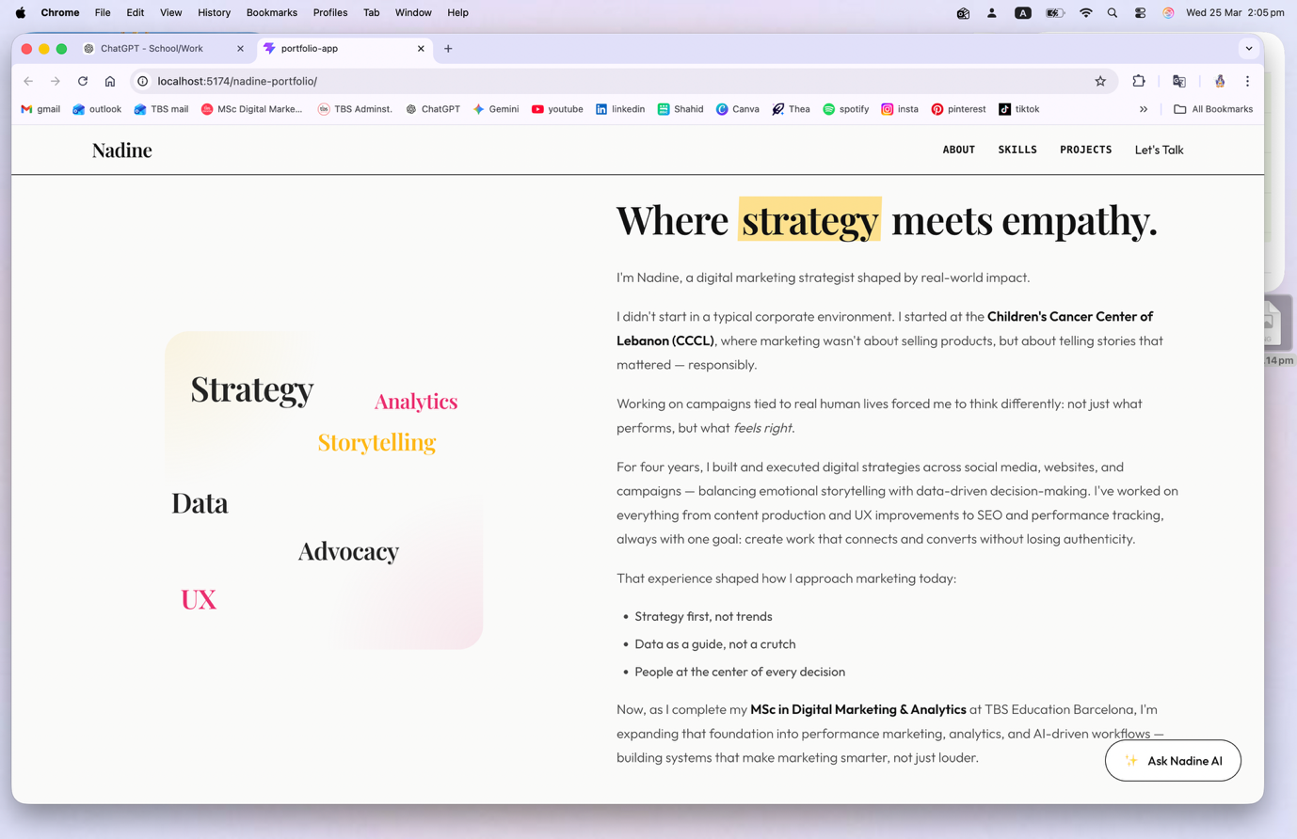
Something about this about section annoys me, I don’t like whatever is going on on the left side. And I don’t like the title “where strategy meets empathy” I want something within “about me” but not exactly that as a title .
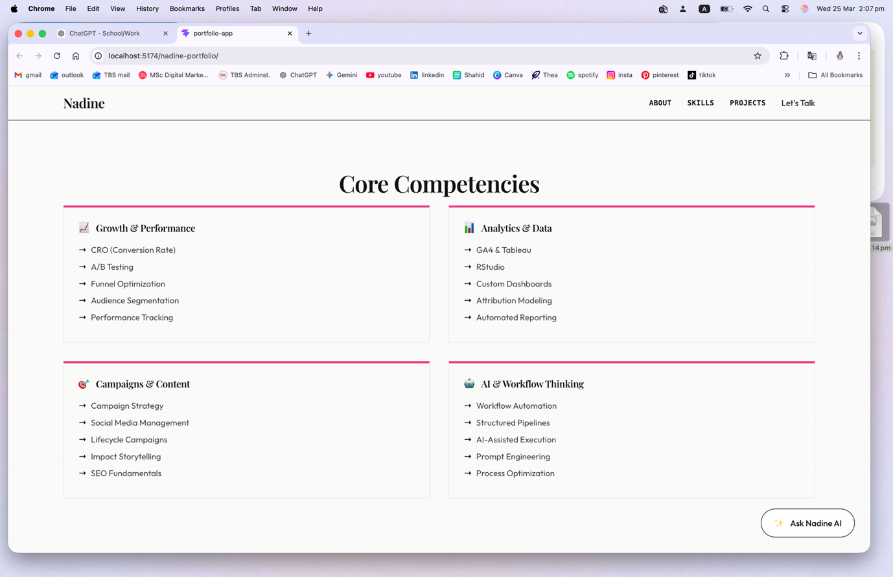
In this section, turn theses boxes into squares (or a bit into rectangule) but not like that since theres a lot of empty space going on in the entire rectangle.
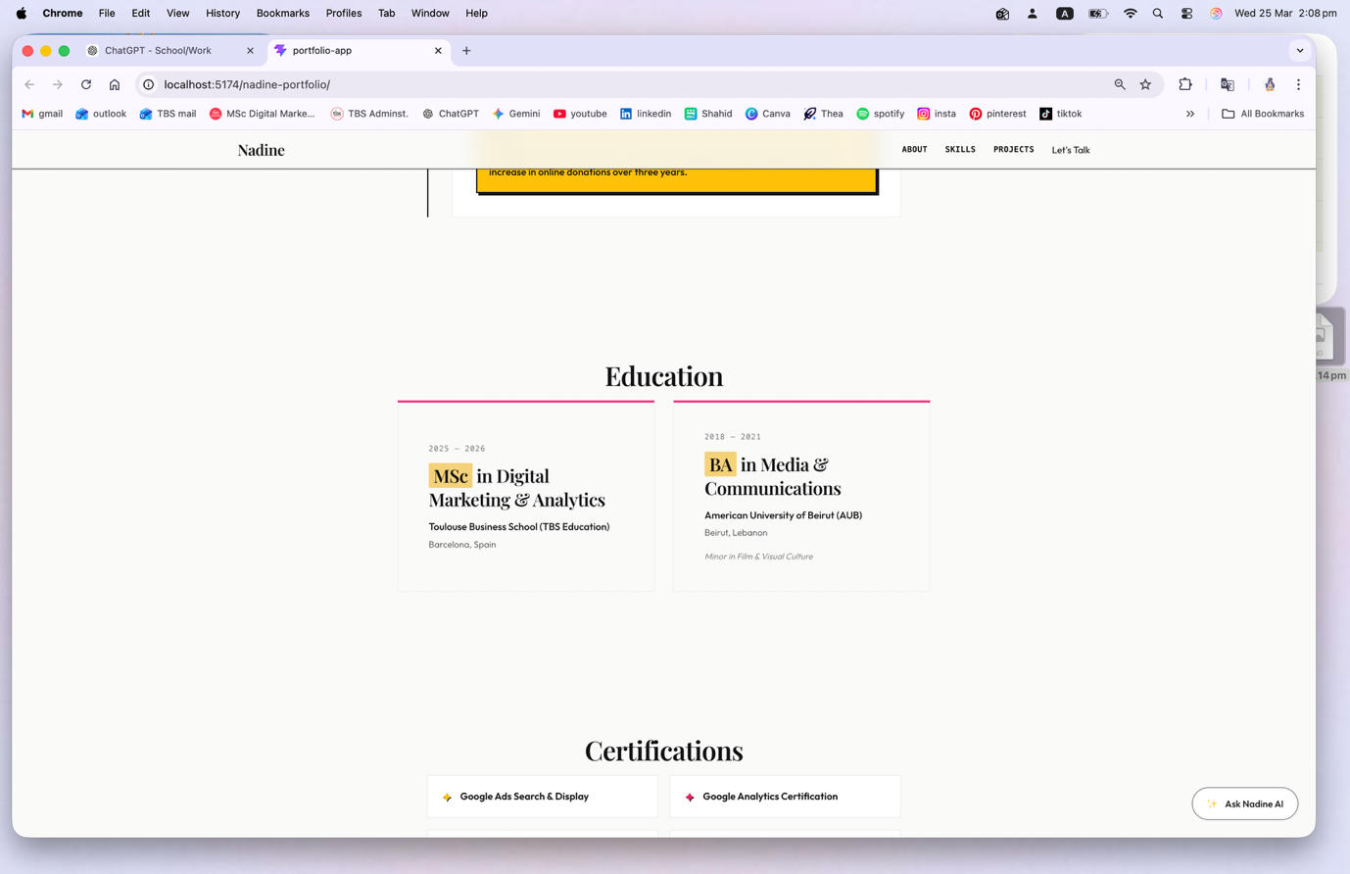
Therers a lot of space between each section, like look at all the empty space between education certifications etc, I need a cohesive feel all throughout, proper spacing out everywhere.
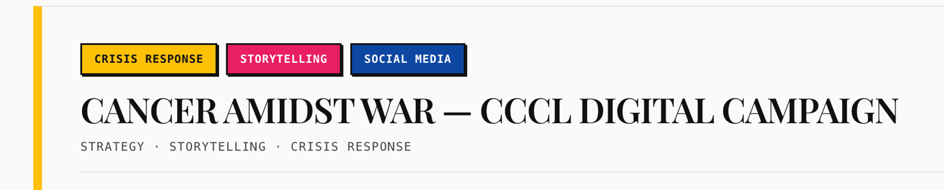
In this section, do not rewrite ‘strategy, stroyelling..’ under the title, we already have them in their boxes. Same goes to the other projects.

